Section B

# Application

Write the HTML/CSS/JavaScript code which would display something similar to the following login page. On small screen sizes (e.g. under 800px wide, the right side panel should not be visible.

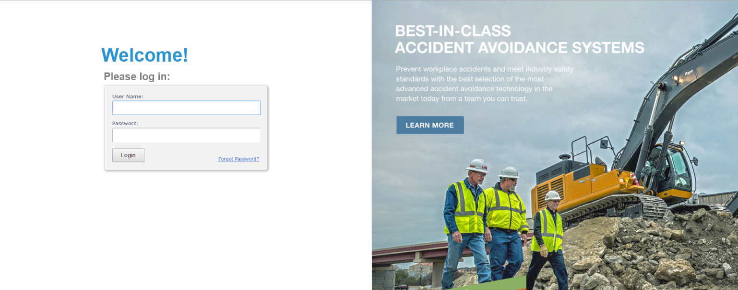

# Application

Write the HTML/JavaScript code that would display the *Car / Truck / Crane* images when their corresponding check boxes are checked.

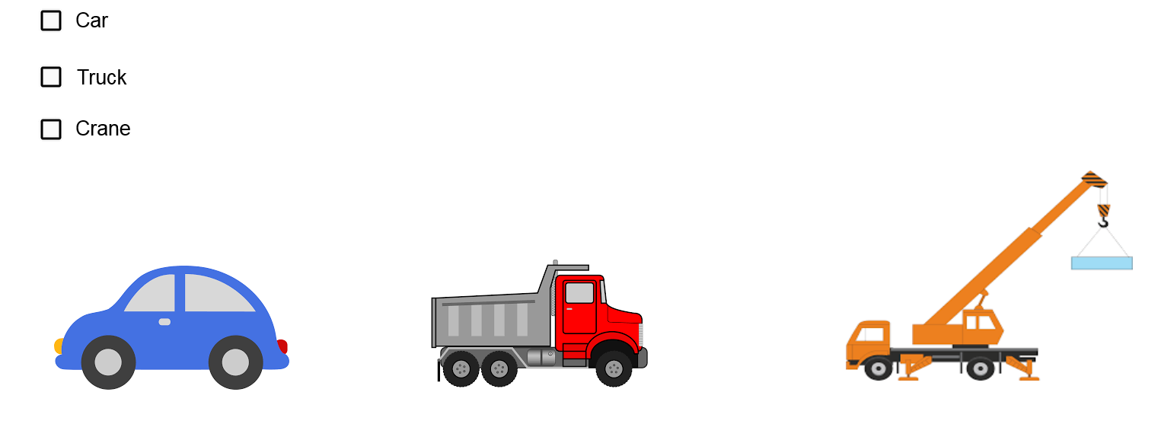

# Application

Write an **ASPX/C# Web application** which would open a *Default.aspx* page and redirect to a *Login.aspx* page if a “*User*” object is not found in *Session*. On the contrary, if the “*User*” object is found, should redirect to a *Welcome.aspx* page. For the *Login.aspx* page: a login is successful if either *First Name* or *Last Name* contains the abbreviation “**Jr**” (e.g. *First Name*: “Todd Jr.”). After logging in, a “*User*” object must be placed in *Session* and a redirect to *Welcome.aspx* should happen. Attempting to open the *Welcome.aspx* page without the “*User*” object in *Session* should redirect to *Login.aspx* page.

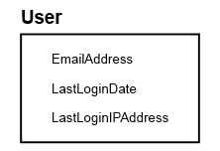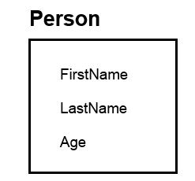

Inherits from

*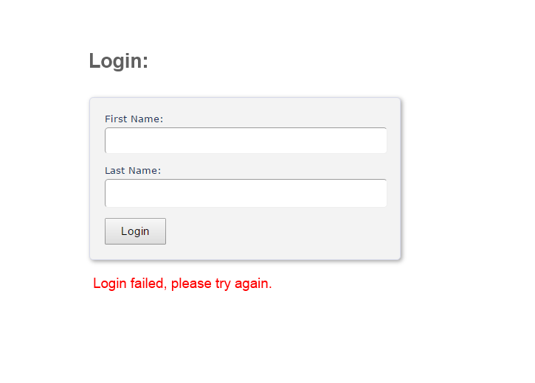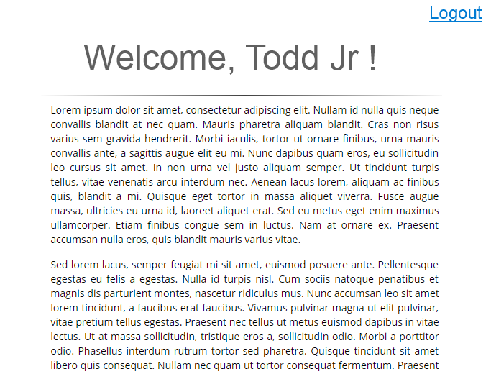Login.aspx: Welcome.aspx:*

# Application

How would you approach the development of a mobile application having the following features:  
- **authenticates a user,** then  
- if allowed, that user would **edit and save other user profiles** to a Web application  
- when those users whose profiles were updated log in using the same application on their mobile devices, they should receive (only once) a **notification that their profile was updated**, together with the name of the person that did the update and the date of the update.  
(you may assume that the Web application has the ability to save/load data to/from a SQL database)

**Solution:**

Personally, I like to see solutions from the high-level first, this I will design as tiers of solution as below

Mobile Device <-> Web App <-> Business/DataAccess <-> SQL Database

The solution to the scenario painted above lies mainly in how the data is stored in the database. Users are stored in the user table. Each time a user with ModifyAccess = true modifies a profile, a new record is created in the UpdateJournal.

On login of any user, the application checks the UpdateJournal table for any record with login user = UpdateUser and having Notified= false. Such users are sent the one-time notification (which includes UpdatedBy and UpdateTime) on the app and this Notified field set to true.

**::: Table Schema**

**Table: User**

UserId: int

Username: string

Password: string (hash)

ModifyAccess: bool

Other Userinfo ….

**Table: UpdateJournal**

UpdateUser: string

UpdateTime: DateTime

UpdatedBy: string

Notified: bool